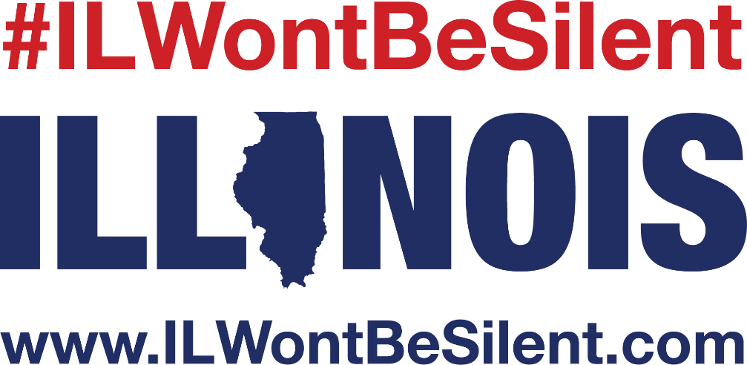

Below are some examples that your organization or business can post on social media. They can be copy and pasted for the post or you can record someone with your organization and post the video.

- The key to preventing suicide is education. Learn the statistics associated with suicide and the warning signs often displayed. By being educated on this Silent Epidemic, you could help save a life. Learn more at www.ILWontBeSilent.com #ILWontBeSilent
- Each week, we lose __ Illinoisans to suicide. #ILWontBeSilent about the epidemic of suicide and I challenge you to do the same! Visit, www.ILWontBeSilent.com to learn how you could make a difference in someone’s life today. #ILWontBeSilent
- Would you know how to recognize or respond if friend is struggling with thoughts of suicide? I am pledging not to be silent, and you can too! Visit www.ILWontBeSilent.com and find out more. #ILWontBeSilent
- Learn the warning signs associated with suicide. Suicide is preventable. #ILWontBeSilent
- Suicide is one of the leading causes of preventable death in our nation. Learn how you can help www.ILWontBeSilent.com #ILWontBeSilent
- We have joined as one of the Collaborative Partners with #ILWontBeSilent and we are going to raise the conversation about suicide prevention. Join us at www.ILWontBeSilent.com
- Raise the national conversation on #suicideprevention. Visit www.iwontbesilent.com #iwontbesilent

